**Project Design Phase-II**

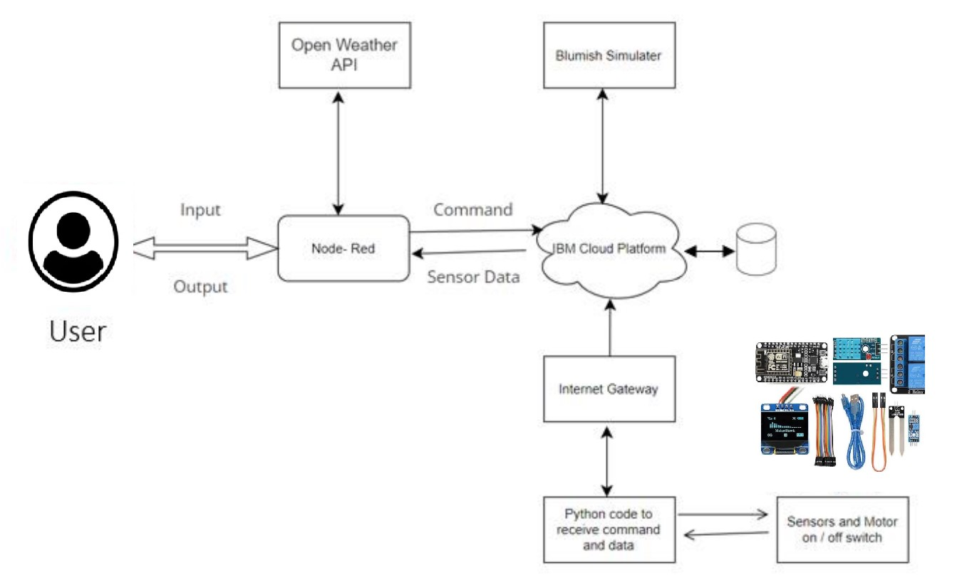**Data Flow Diagram & User Stories**

|  |  |
| --- | --- |
| Date | 15 October 2022 |
| Team ID | PNT2022TMID05092 |
| Project Name | Project – Smart Farmer-IoT Enabled smart Farming Application |
| Maximum Marks | 4 Marks |

**Smart Farming Application Flow Diagram (simplified)**

**Data Flow Diagrams:**

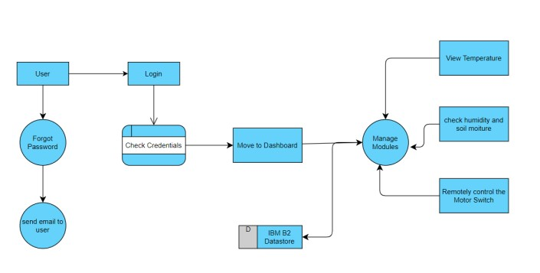

**User Stories**

|  |  |  |  |  |  |  |
| --- | --- | --- | --- | --- | --- | --- |
| **User Type** | **Functional**  **Requirement**  **(Epic)** | **User**  **Story**  **Number** | **User Story / Task** | **Acceptance criteria** | **Priority** | **Release** |
| Customer  (Mobile user) | Registration | USN-1 | As a user, I can register for the application by entering my email, password, and confirming my password. | I can access my account / dashboard | High | Sprint-1 |
|  |  | USN-2 | As a user, I will receive confirmation email once I have registered for the application | I can receive confirmation email & click confirm | High | Sprint-1 |
|  |  | USN-3 | As a user, I can register for the application through Gmail |  | Medium | Sprint-1 |
|  | Login | USN-4 | As a user, I can log into the application by entering email & password |  | High | Sprint-1 |
| Customer  (Web user) | Dashboard | USN-5 | As a User can view the dashboard, and this dashboard includes the check roles of access and then move to the managed modules. | I can view the dashboard in this smart farming application system. | High | Sprint 2 |
|  |  | USN-6 | User can remotely access the motor switch | In the smart farming app | High | Sprint 3 |
| Administrator |  |  | As a user once views the managed modules this describes the Manage system Admins and Manage Roles of User and etc. |  |  | Sprint 2 |